NEFOM – North European Forest Mycologists

SNS network 2024
NEFOM is a research network that strive to strengthen the collaboration between research groups working with ecology, evolution and taxonomy of forest fungi and improvement of molecular techniques and data management via the UNITE data base. NEFOM has members from seven Nordic and Baltic countries and affiliated members in several other North European states.

Our main network activity during 2024 was a two-day scientific meeting at Ájtte – Svenskt fjäll- och samemuseum – in Jokkmokk, followed by excursions to outstanding nature reserves and national parks in the region. The theme of the meeting was Multiple values of Northern forests, and about 35 scientists, stakeholders and students participated in the meeting. We discussed ongoing research projects and methodological developments based on presentations by network members.

A highlight in the meeting was the session on forestry and Sámi reindeer herding with presentations by experts from the Ájtte museum and a reindeer herder from the Jokkmokk area. This led to interesting and enlightening discussions about potentials for forest management that may benefit both mycological nature values and reindeer husbandry in low-productive Northern boreal forests. Participants surely achieved a deeper understanding for the complexity of decisions behind the multiple uses of the Northern boreal forest landscape.

After the meeting most participants joined excursions to some of the magnificent forests with extremely high mycological values near Jokkmokk, the Piatis nature reserve and Muddus National Park. Here mycologists at all levels got the chance of exploring fungal fruiting bodies and belowground mycelia in their fully-fledged form.

NEFOM members also contributed to international scientific meetings and research education in Mycology during 2024. NEFOM also continued the work with open access to forest biodiversity data by building digital services for researchers, stakeholders and the public.

Please see below for some snapshots from the Jokkmokk meeting and excursions.

Karina Clemmensen, SLU
NEFOM coordinator 2024

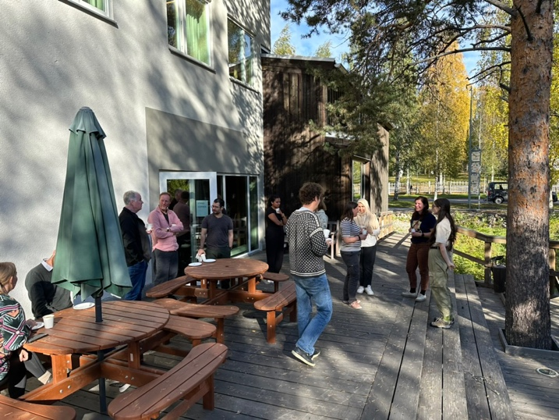
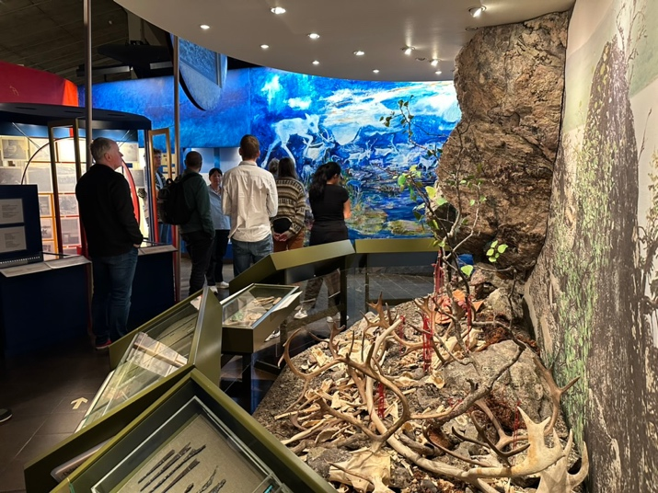
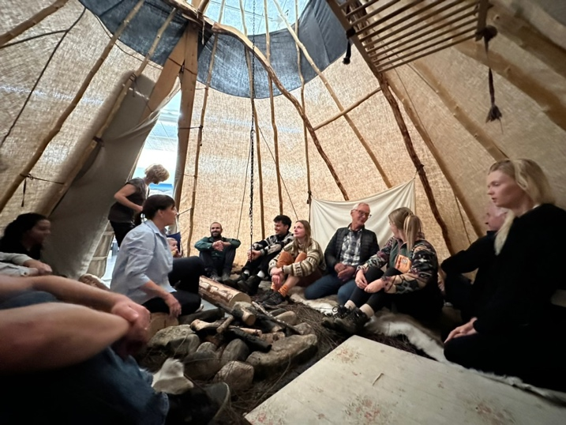
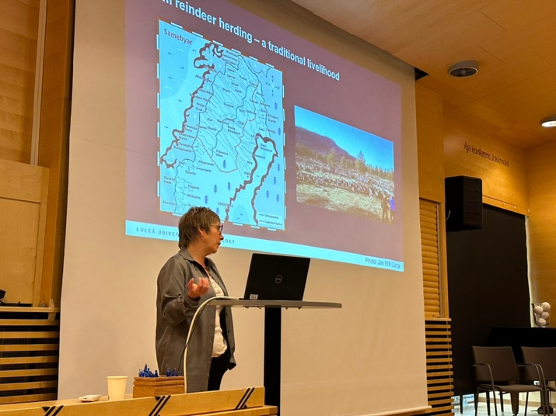
Ájtte – meeting venue and museum visit

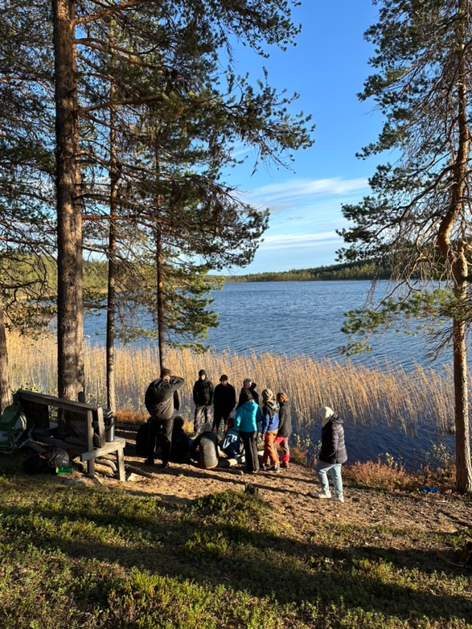
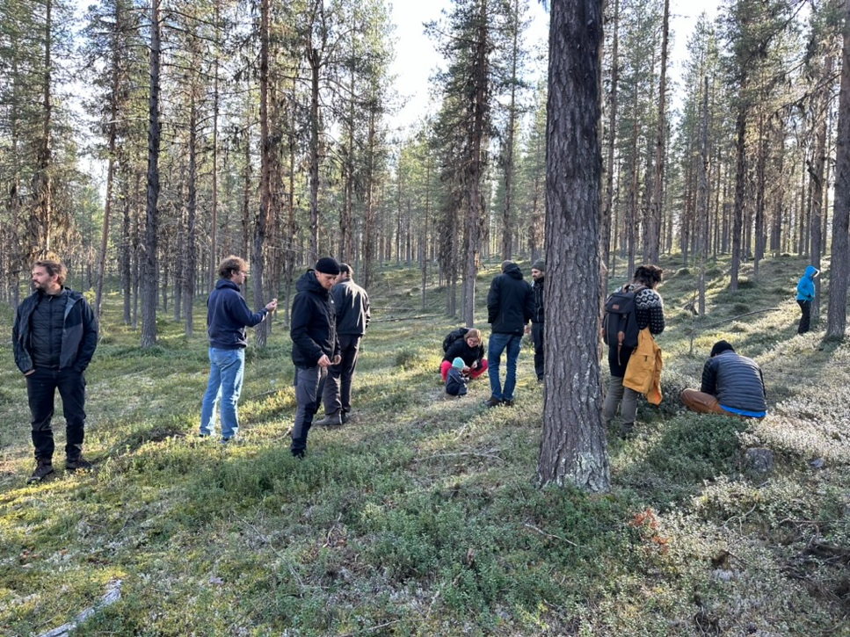
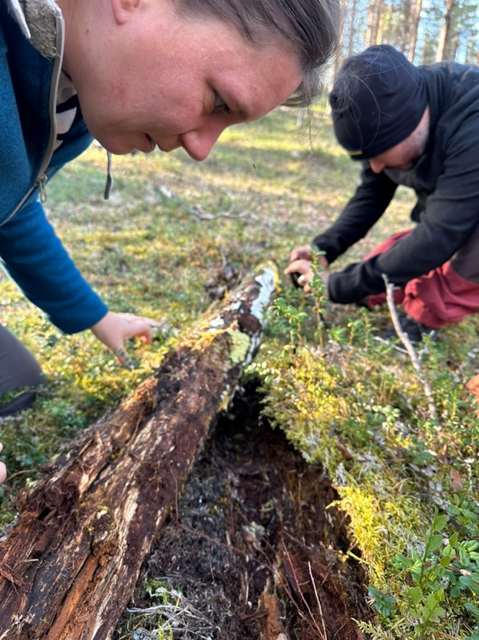
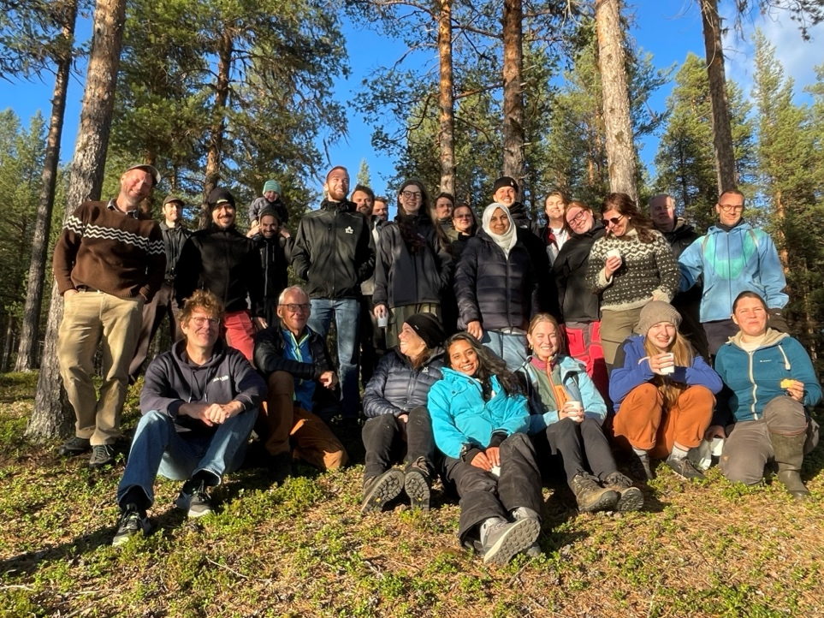
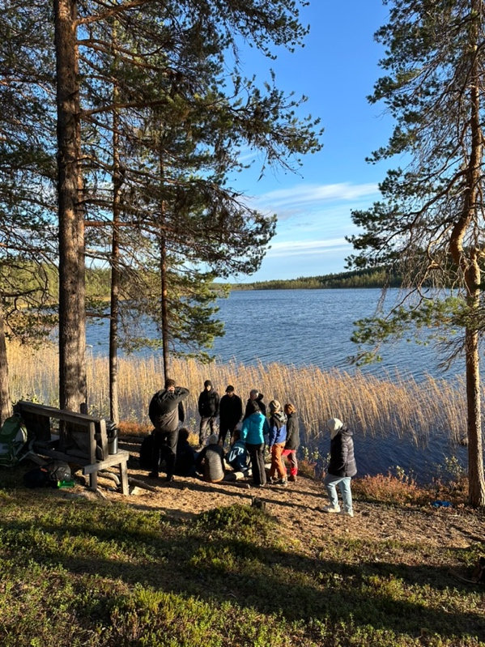
Piatis mycology excursion

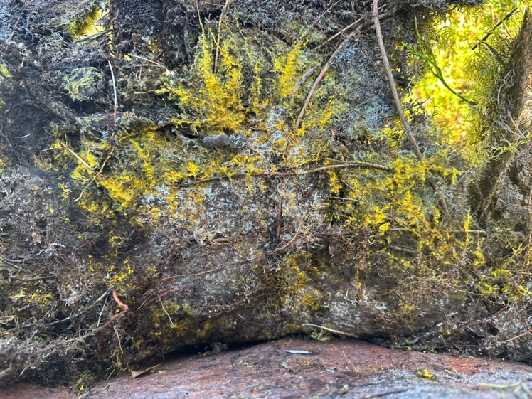
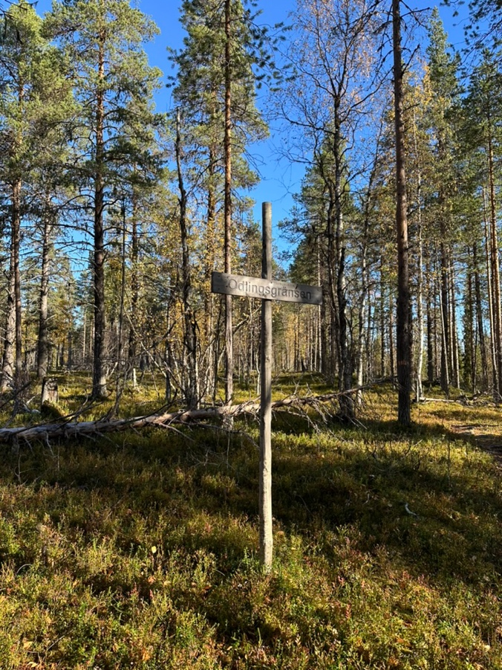
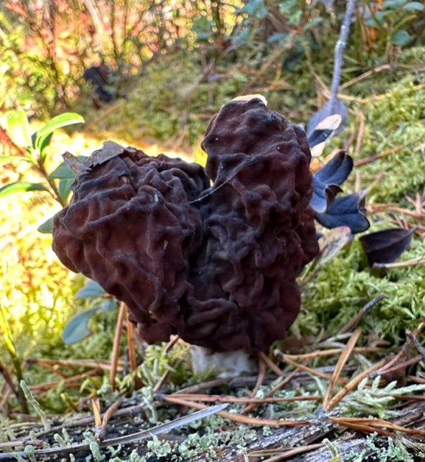
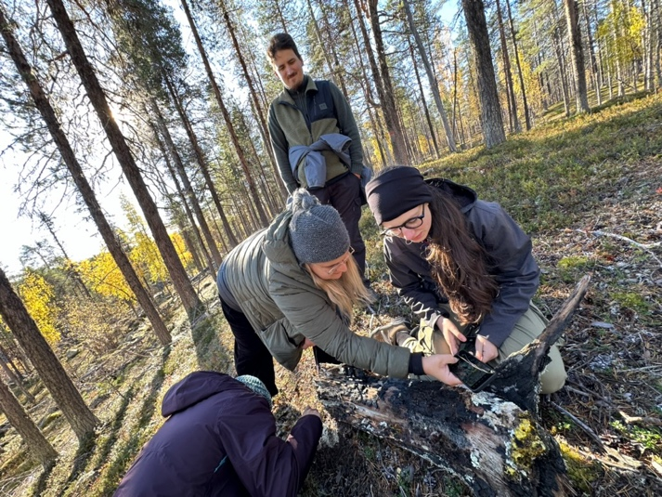
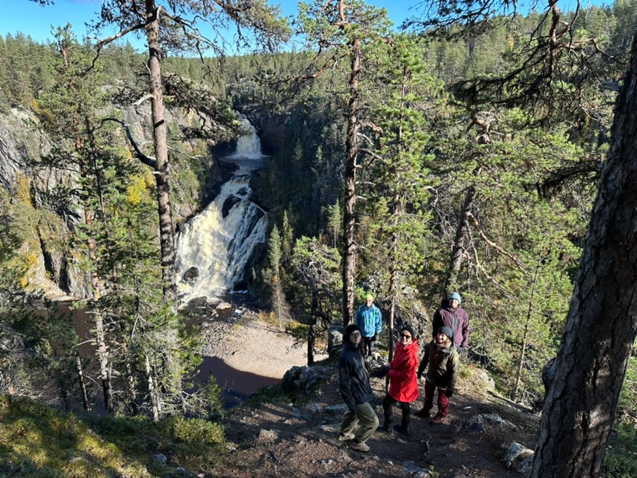
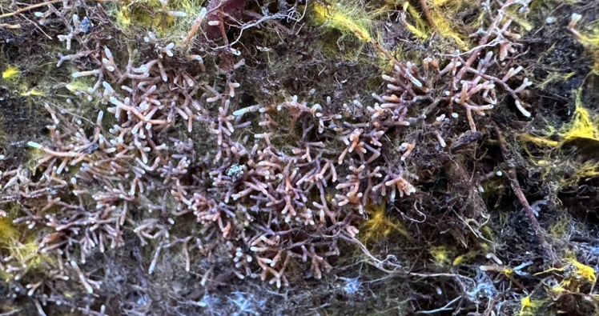
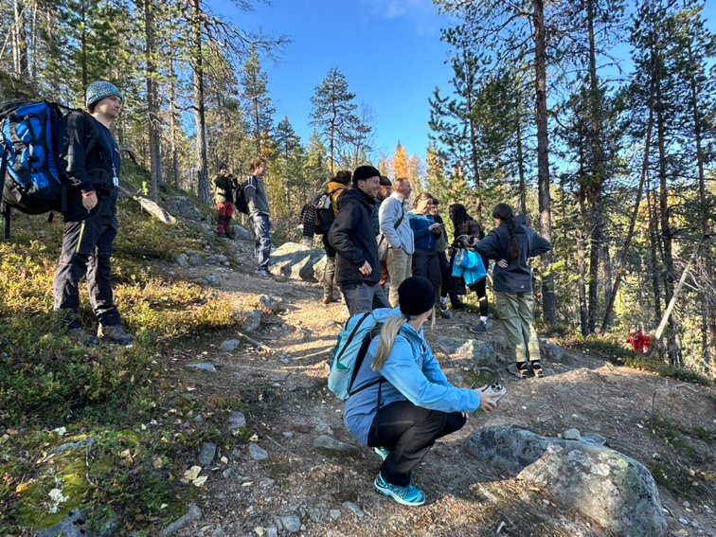
Muddus excursion

