New diseases and harmful insects in woodlands of Northern Europe

Network title: Alien forest pathogens and pests in the changing environment: focus on North Europe (N2023-01)

Contact person: Rimvydas Vasaitis (rimvys.vasaitis@slu.se; Department of Forest Mycology & Plant Pathology, Swedish University of Agricultural Sciences, P.O. Box 7026, 75007 Uppsala)

Preamble: On 12 – 13th of September 2023 a group of forest pathologists and entomologists gathered in Visby, Gotland Island. The participants (a total of 20) represented all five Nordic Countries, three Baltic States, and Ukraine, and were also joined by the local stakeholders representing Swedish Forestry Agency and Gotland Administration. The purpose was to conduct scientific workshop focusing on invasive tree pests and diseases emerging in each respective country, and to participate in excursion to damaged woodland sites of Gotland. Benefits for the Nordic Society of forest pathologists and entomologists were significant, as the exchange of knowledge has been achieved regarding ongoing activities, problems, and forest health situation in each participating country. Seventeen extended abstracts of the presentations have been accepted for publication in WoS Impact Factor journal Baltic Forestry. Moreover, several early-stage researchers have made presentations and have been introduced into the research community.

Short summaries of the country presentations (extended abstracts of each are being published open access in journal Baltic Forestry)

Presentation from Iceland focused on damages caused to trees by introduced insect pests. The most important introduced birch pests are three species of leaf-mining insects, virtually small moths, larvae of which feed inside the leaves. Those are Heringocrania unimaculella, Scolioneura betuleti and Fenusella nana. Their distribution area is expanding. The most important disease is birch rust, caused by fungus Melampsoridium betulinum, damaging trees in winter and predispose them to other damages. (Brynja Hrafnkelsdóttir, Icelandic Forest research)

Presentations from Finland targeted both invasive diseases and insect pests that have already been established in north Europe, but also the potential new arrivals. Reported disease studies included recent findings on invasive tree-infesting fungi Corinectria fuckeliana and Neonectria neomacrospora causing canker wounds on stems and branches of spruce and fir, and Diploidia sapinea, causing shoot blight of pine. As examples of potential new arrivals, two insect species were discussed: bronze birch borer (Agrilus anxius), and four-eyed fir bark beetle (Polygraphus proximus) that, upon eventual invasion, could potentially extirpate European birch and fir. (Anna Poimala, Tiina Ylioja & Matti Koivula, LUKE)

From Sweden, the first reported study concerned the occurrence and pathogenicity of Corinectria spp. - a canker disease of fir (Abies), and its eventual association with Polygraphus proximus. The disease is caused by previously unknown fungi. The next presentation concerned rust fungus Thekopsora areolata that infects cones and young shoots of Norway spruce. It is the actual problem, as today there is a lack of seeds produced in seed orchards in many planting zones, mainly due to irregular flowering, but also due to regular outbreaks of the disease. The following presentation concerned seedborne pathogens: Siroccocus conigenus, Sydowia polyspora, Fusarium sp., and Diplodia sapinea. Subsequent investigation focused on Diplodia sapinea as a contributing factor in the crown dieback of Scots pine after a severe drought. Finally, a new phenomenon of damage in birch stands has been reported. The symptoms include crown thinning, dead shoots, and dead buds, losing the top, stem breakage, and tree death. (Audrius Menkis, Åke Olson, Rebecca Larsson & Matilda Stein Åslund, SLU)

From Norway, a review was presented analysing biological traits of invasive ash dieback pathogen Hymenoscyphus fraxineus in comparison to those of the harmless ash saprotroph Hymenoscyphus albidus, indigenous to Europe. It was pointed out that, the first (invasive pathogen) fungus has dominant strategy in unstable or unpredictable environments, while by contrast, H. albidus (native saprotroph) has dominant strategy in stable or predictable environments. (Ari Hietala, NIBIO)

The results were presented on long-term ash dieback monitoring in Estonia. The disease affects trees in all age classes, regardless of growing conditions. The overall health of seedlings has improved significantly when compared to the previous surveys, yet the western part of the country stands out with its large percentage of dead trees among both seedlings and old trees. Exotic ash species growing in Estonian parks and arboreta are in good overall health, only Fraxinus mandshurica seems to suffer more. (Ahto Agan, Estonian University of Life Sciences)

In Denmark, ash dieback is a forestry problem, and it is expected that it will gradually get worse. However, most ash forests will last for years, which may provide the possibility for species survival and further cultivation. Indeed, current experiences demonstrate that many old ash trees persist, particularly in open landscapes and parks. Therefore, it is suggested to keep ash wherever possible. Second presentation concerned the disease named Acute Oak Decline (causing cracks and necrotic lesions on the bark) that during the last decade is being observed in the United Kingdom. It recently invaded mainland Europe, and established within wide geographic and climatic range, thus has the potential for further spread. (Iben Margrete Thomsen & James Doonan, University of Copenhagen)

Currently two invasive ash pests are present in Ukraine, dieback causing fungus Hymenoscyphus fraxineus, and the wood-boring buprestid beetle Emerald ash borer (Agrilus planipennis). The beetle has been for the first time detected in eastern Ukraine in 2019 and expands westwards. More recently, the evidence was obtained for spread of the beetle by “hitchhiking” (by transport vehicles, as railway and cars), as in 2022 it has been found in the parks of Kyiv, thus at over 500 km distance from its geographically continuous invasive populations in the eastern Ukraine. (Kateryna Davydenko, SLU)

In Latvia, Emerald ash borer (Agrilus planipennis) was monitored in years 2021-2023, yet the beetle has not been detected. Moreover, in 2021, the occurrence of invasive needle pathogens was investigated in woodlands of Scots pine across the country, and Dothistroma septosporum, Diplodia sapinea, and Lecanosticta acicola were detected. The following study presented investigations of wood-inhabiting fungi of deciduous trees: birch, aspen, linden, maple, and oak. Sistotrema brinkmannii and Bjerkandera spp. were dominant saprotrophs. The main pathogens in living stems were Phellinus spp. and Armillaria spp. (Annija Aunina, Darta Klavina, Kristine Kenigsvalde & Zane Saule, Latvian Forest Research Institute)

A decade after first report on Diplodia sapinea in Lithuania, the pathogen was found to be associated with pine dieback, and during the following years, the pathogen spread and caused notable losses. The increase of the damage was observed in 2011, 2017 and 2021, and both mature trees and seedlings exhibited symptoms of the disease. Diseased trees were usually infested by pests. The situation with Ips typographus situation in Lithuania can be equated to a natural disaster. Massive damages were triggered by the warm winters, dry summers and increasing squalls, resulting in high amounts of windbreaks and windfalls. In 2023, abundance of the pest was two and three times higher as compared to 2022 and 2021, respectively. Flight activity and abundant development of the 2-nd generation of I. typographus in 2023 provide strong indication that the damages will increase in 2024. (Aiste Povilaitiene & Jurate Lynikiene, Lithuanian Forest Research Institute)

“… photos from excursions, experiments, discussions or other, related to your network focus, …”

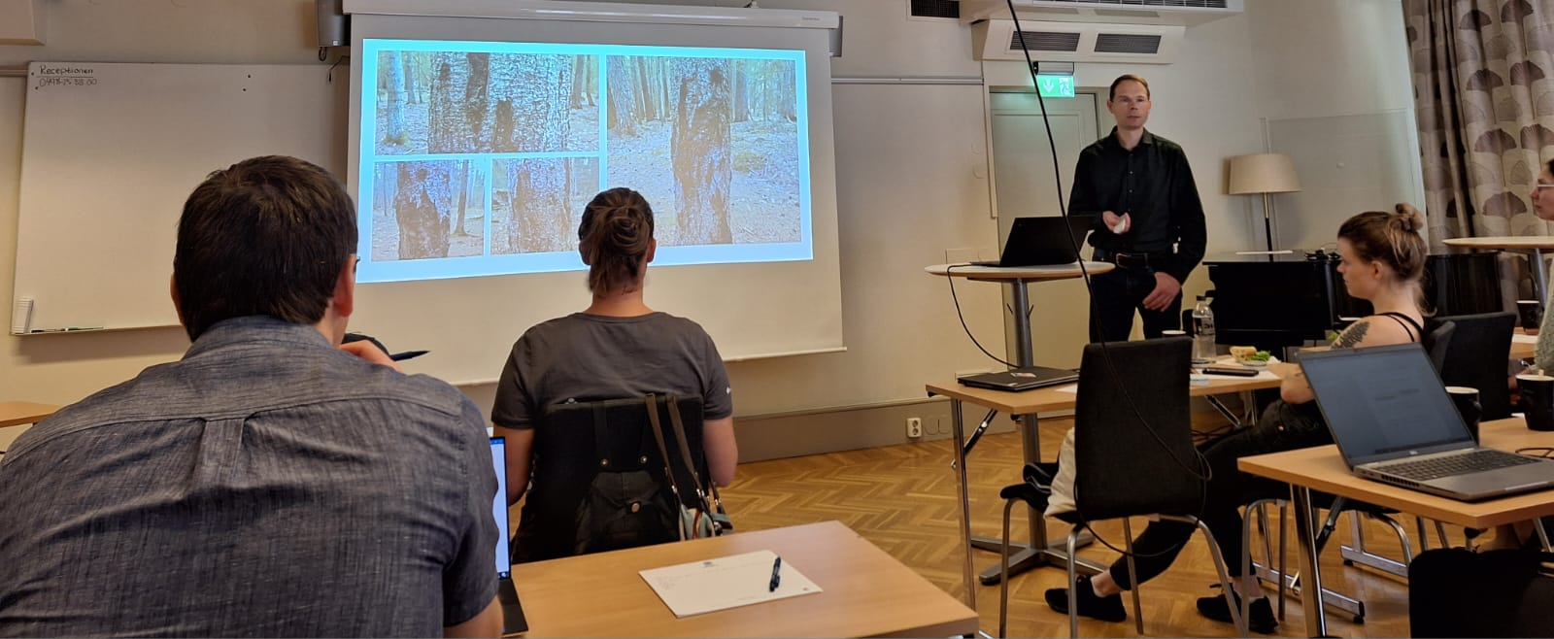
WA0013. Audrius Menkis: “Occurrence and pathogenicity of invasive novel Corinectria spp. – the agents of canker disease of Abies; association with Polygraphus proximus?”

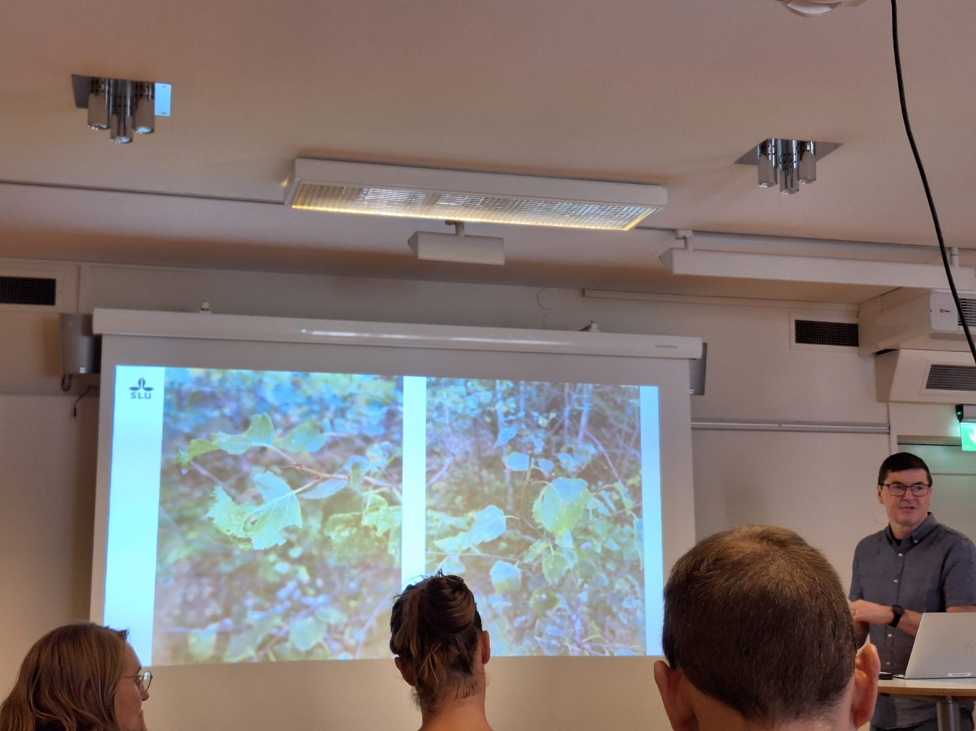
WA0015. Åke Olson: “Declining birch trees in southern Sweden: a new disease phenomenon”

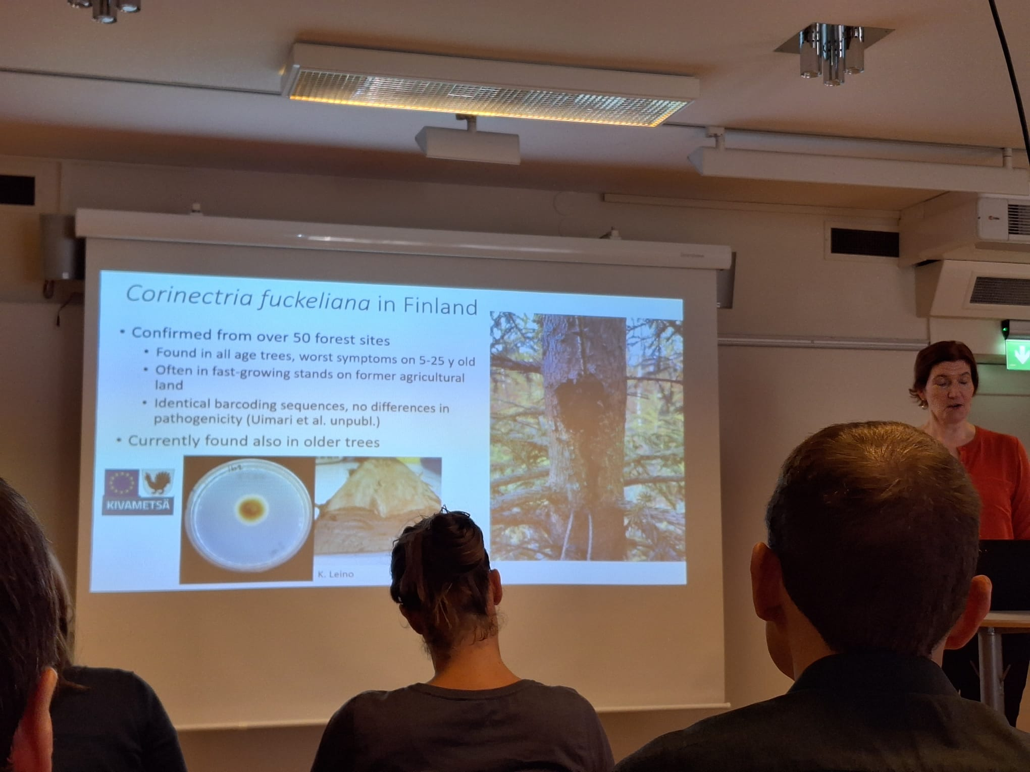
WA0028. Anna Poimala: “Recent findings on invasive tree-infesting fungi Corinectria fuckeliana, Neonectria neomacrospora and Sphaeropsis sapinea”

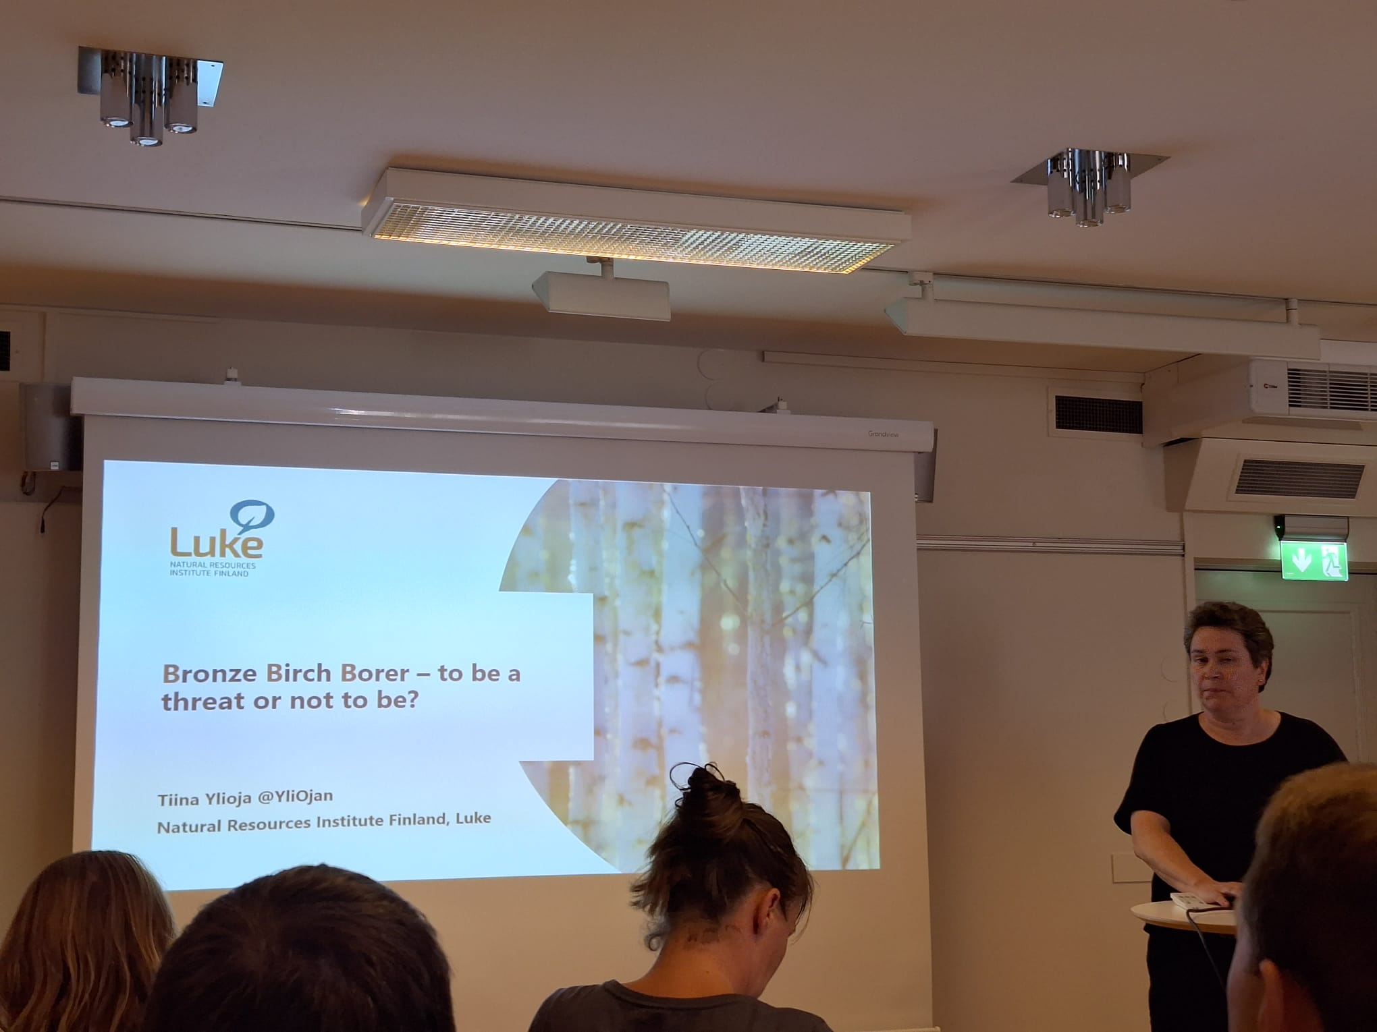
WA0029. Tiina Ylioja: “Bronze birch borer - to be a problem or not to be?”

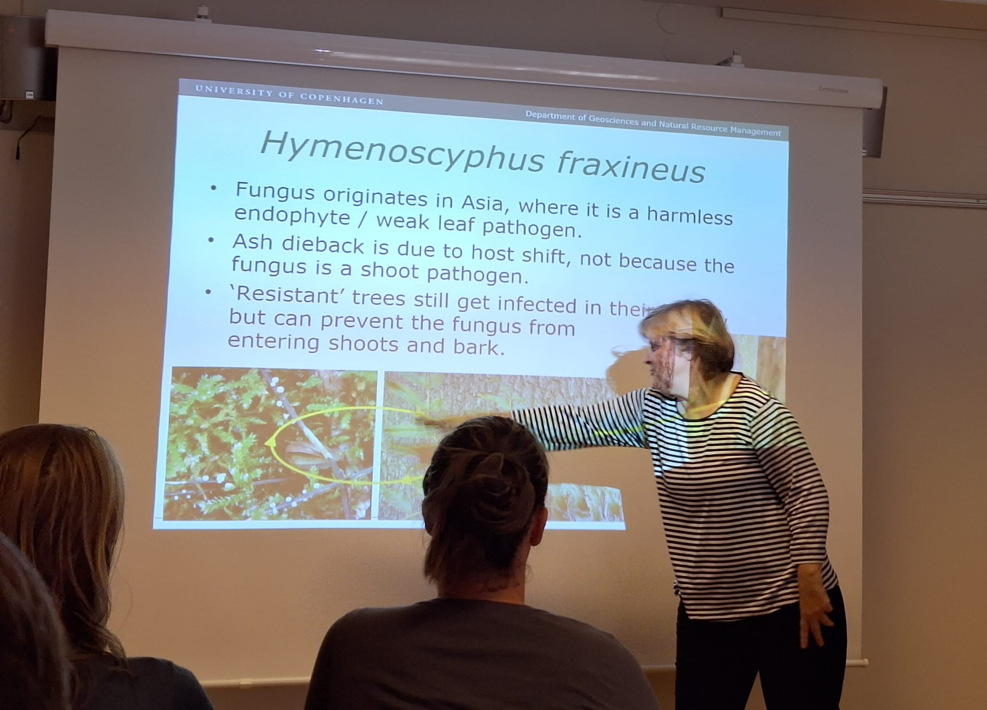
WA0031. Iben M. Thomsen: ”The ash dieback situation in Denmark”

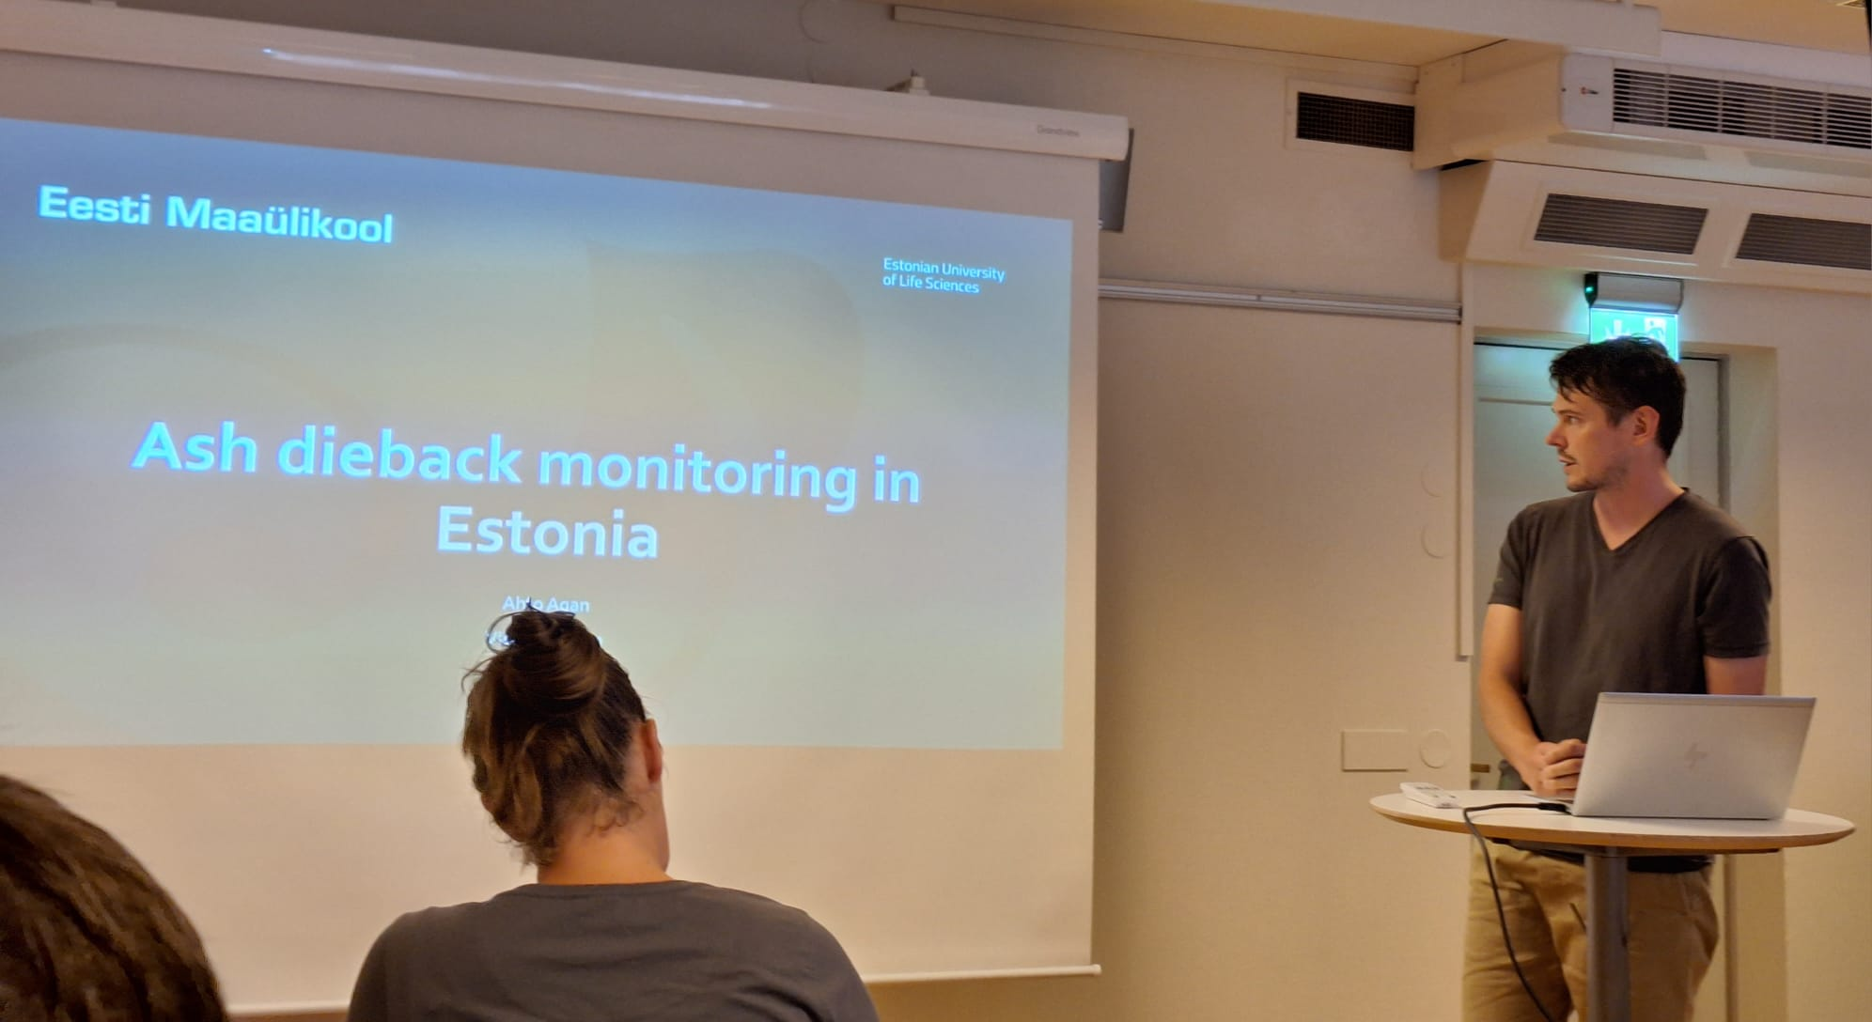
WA0034. Ahto Agan: "Ash dieback monitoring in Estonia"

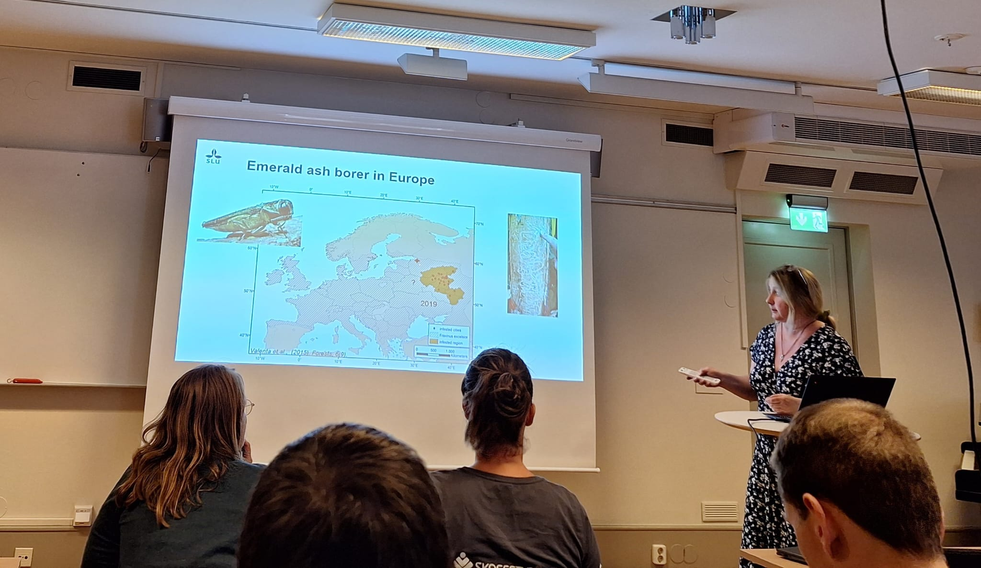
WA0038. Kateryna Davydenko: “Emerald ash borer In Ukraine: a review and distribution survey”

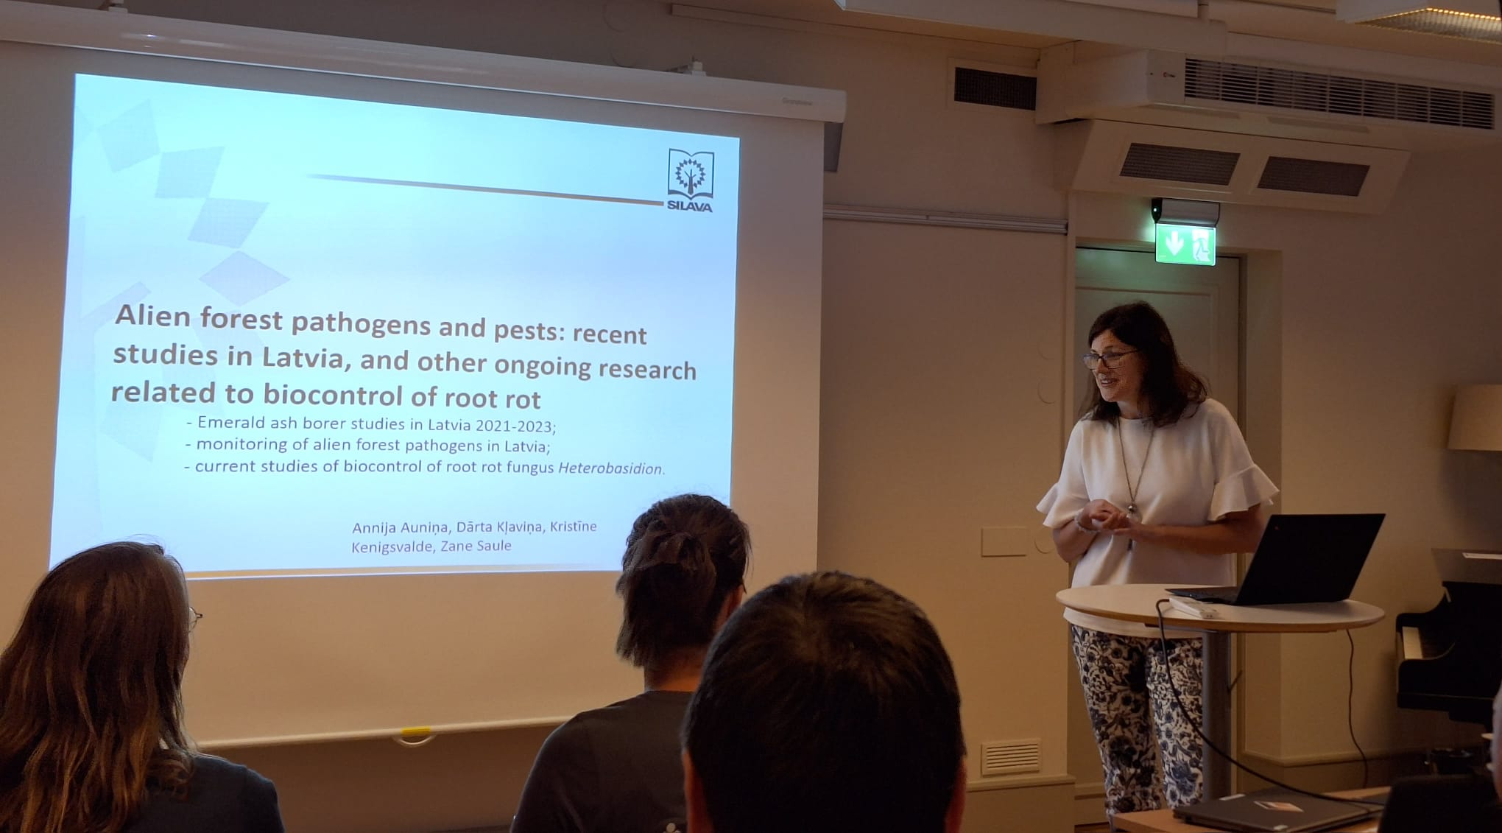
WA0043. Darta Klavina: “Alien forest pathogens and pests: recent studies in Latvia”

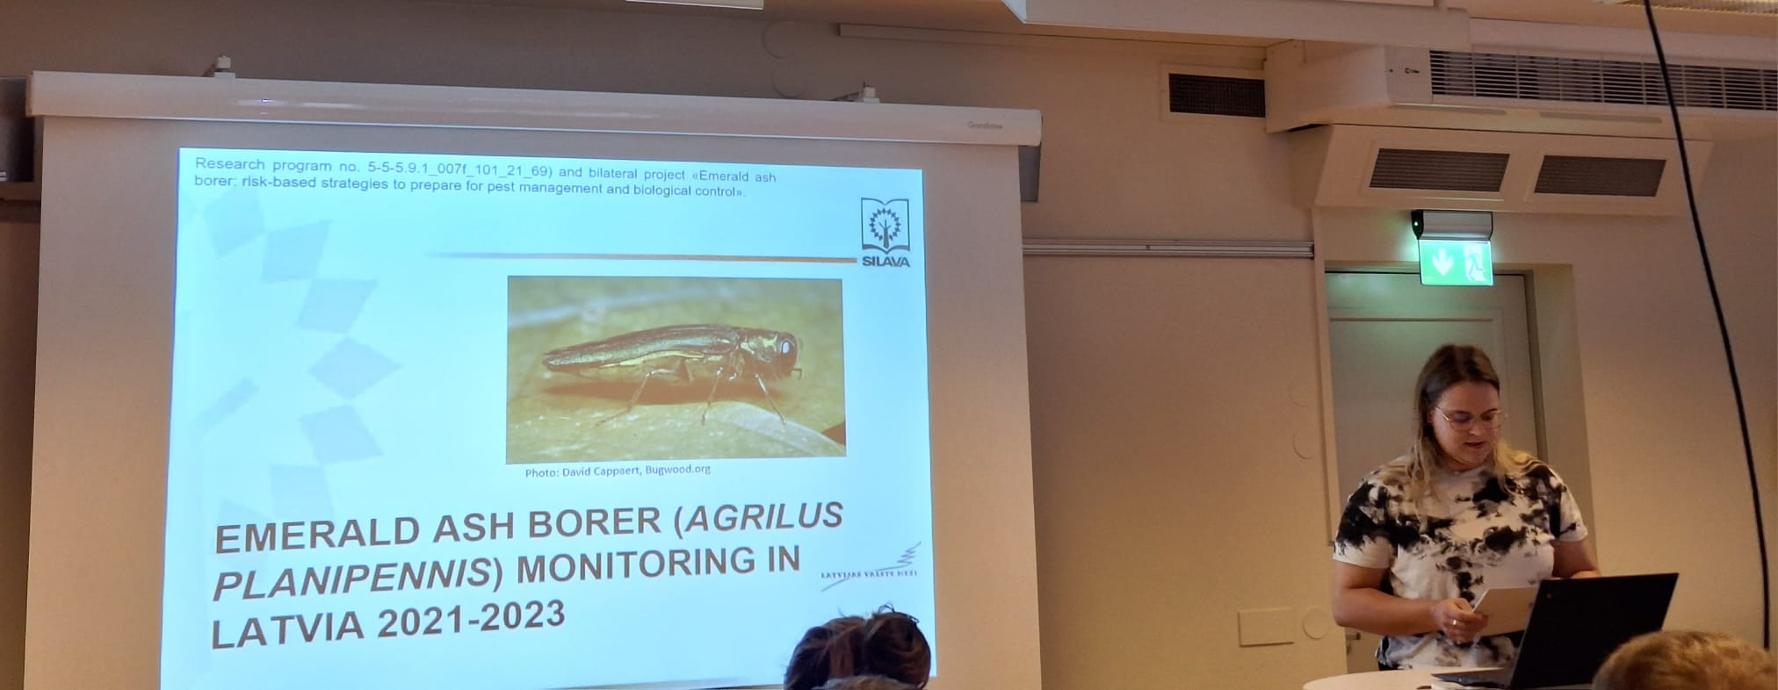
WA0044. Annija Aunina: “Monitoring of Emerald Ash Borer in Latvia”

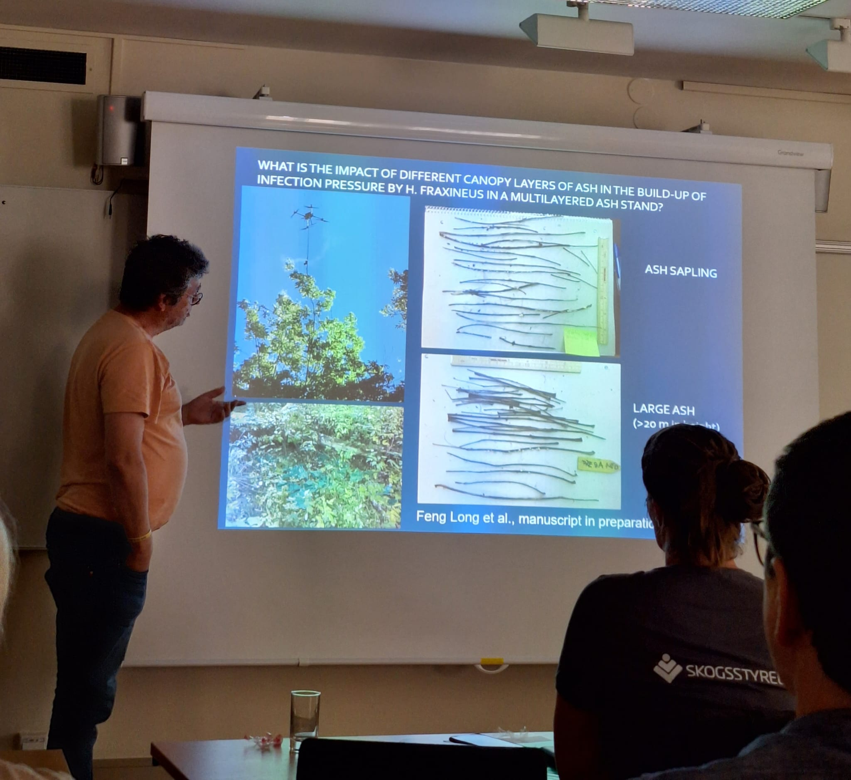
WA0050. Ari Hietala: ”What can we learn by fungal community profiling and trait analysis of the invasive ash dieback pathogen Hymenoscyphus fraxineus and indigenous fungi?”

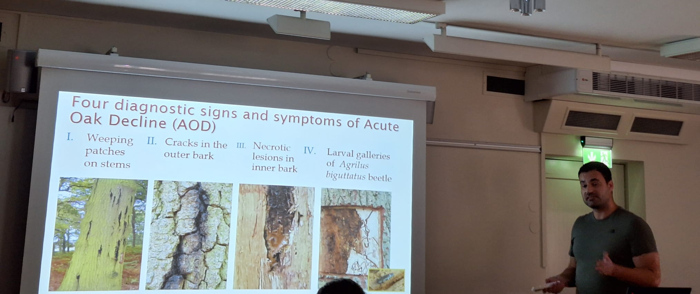
WA0051. James Doonan: “Acute Oak Decline in Europe”

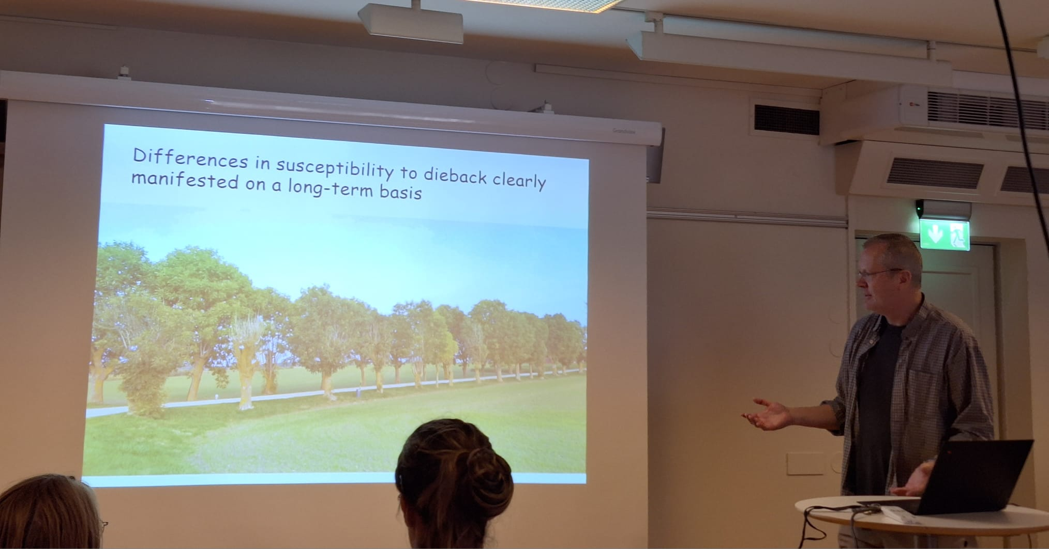
WA0041. Rimvys Vasaitis: “Excursion intro”

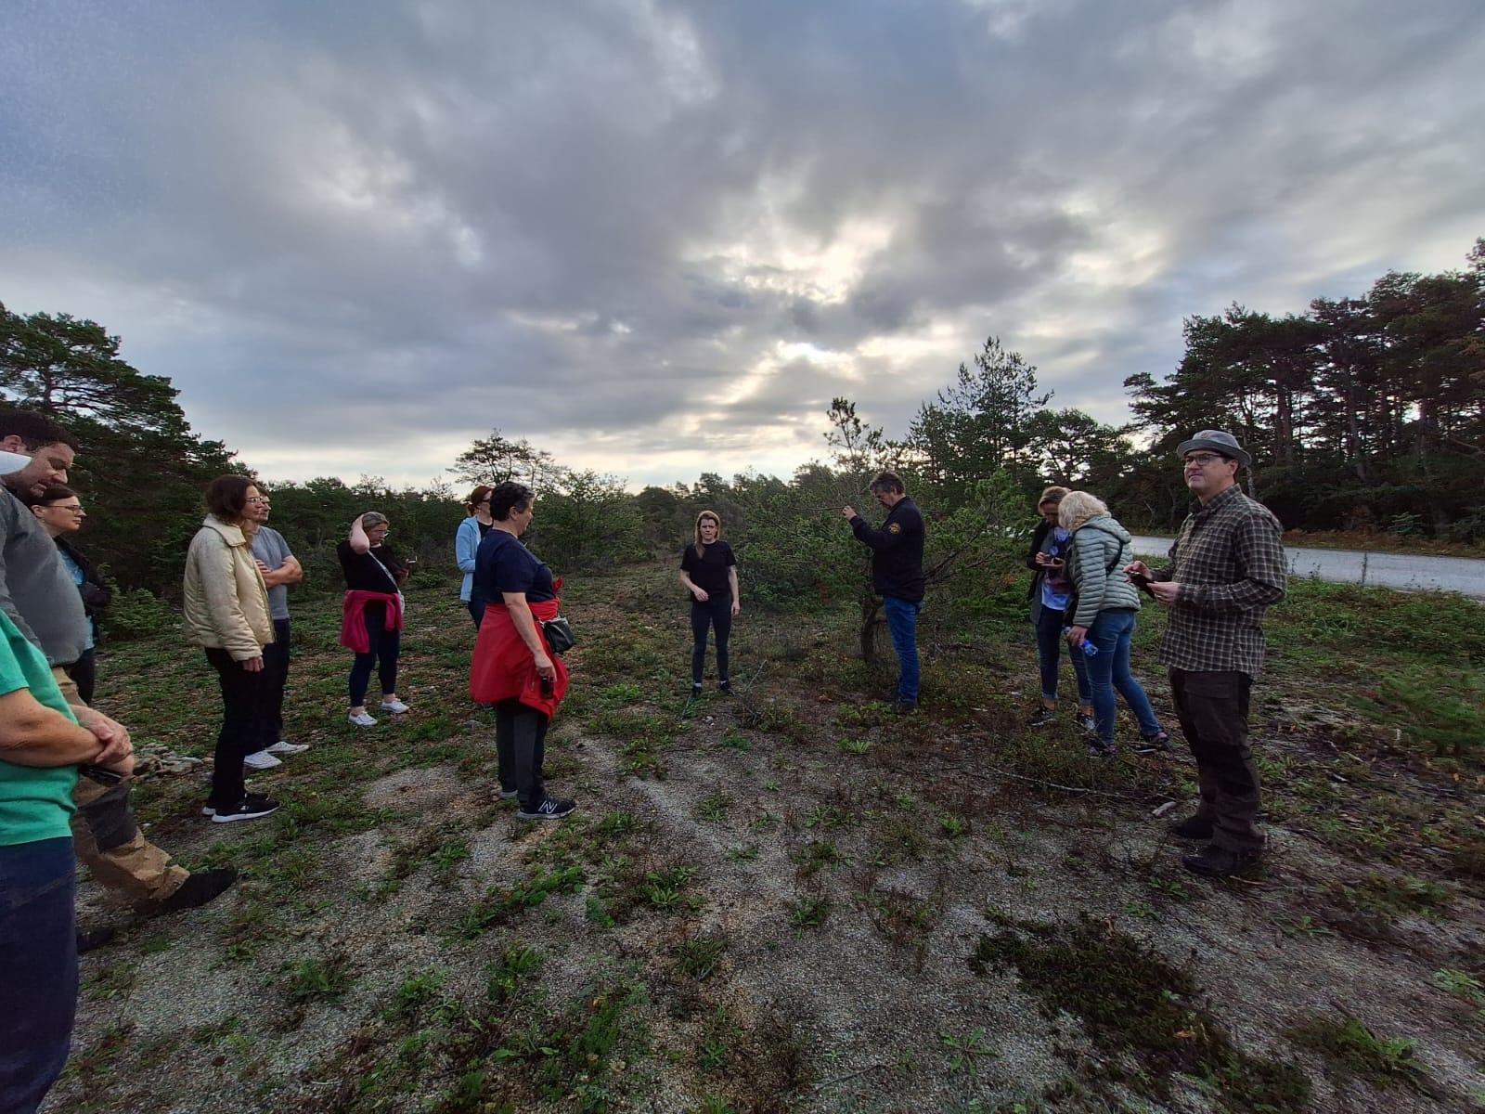
WA0110. Excursion site 1: Diplodia-damaged pine and juniper woodland; Matilda Stein Åslund (center) presents research site of her PhD project.

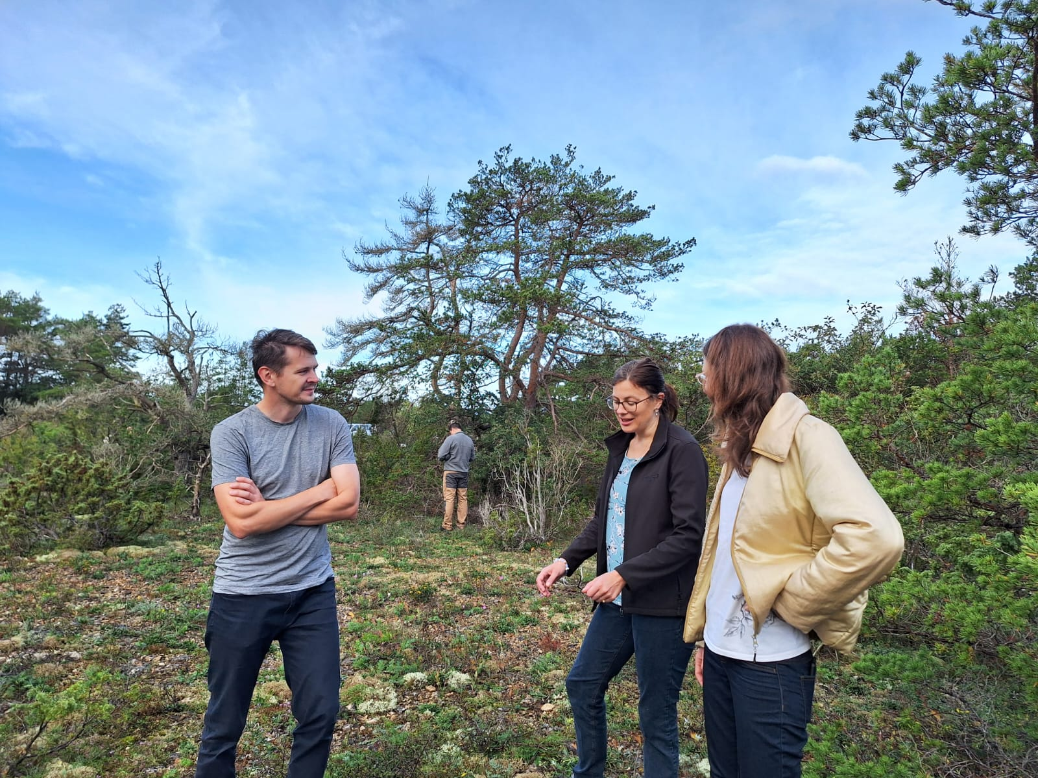

WA0006. Excursion site 1: Diplodia-damaged pine and juniper woodland; Ahto Agan, Darta Klavina and Kristine Kenigsvalde.

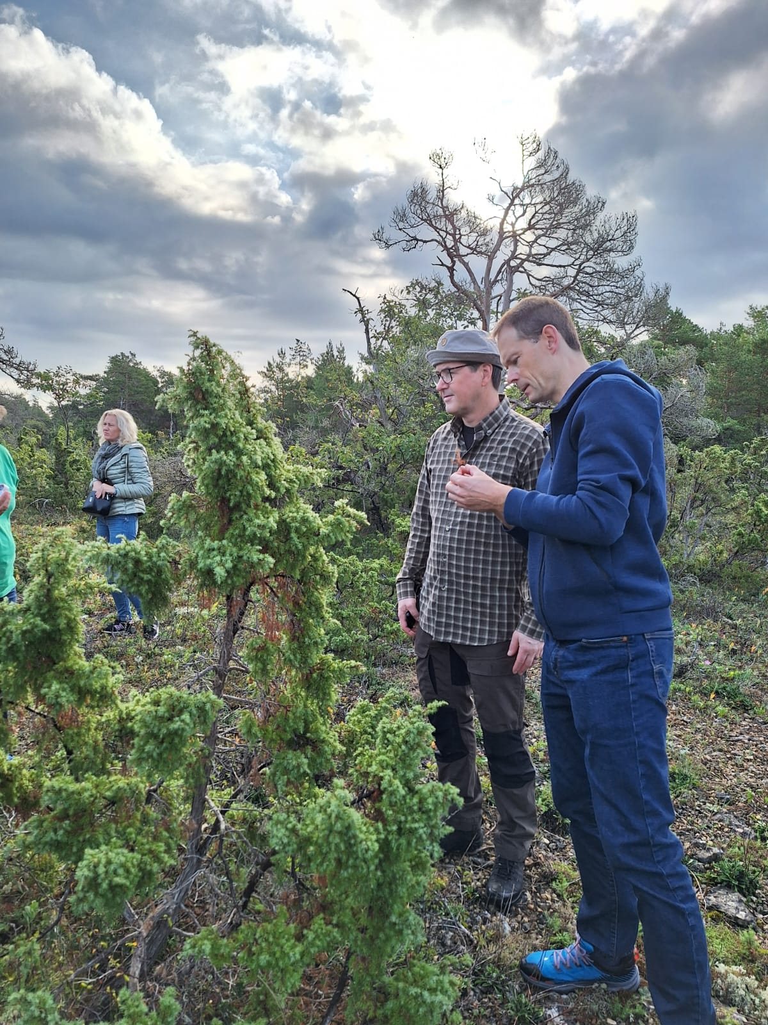
WA0007. Excursion site 1: Diplodia-damaged pine and juniper woodland; Jurate Lynikiene, Åke Olson and Audrius Menkis. (note dead pine in the background)

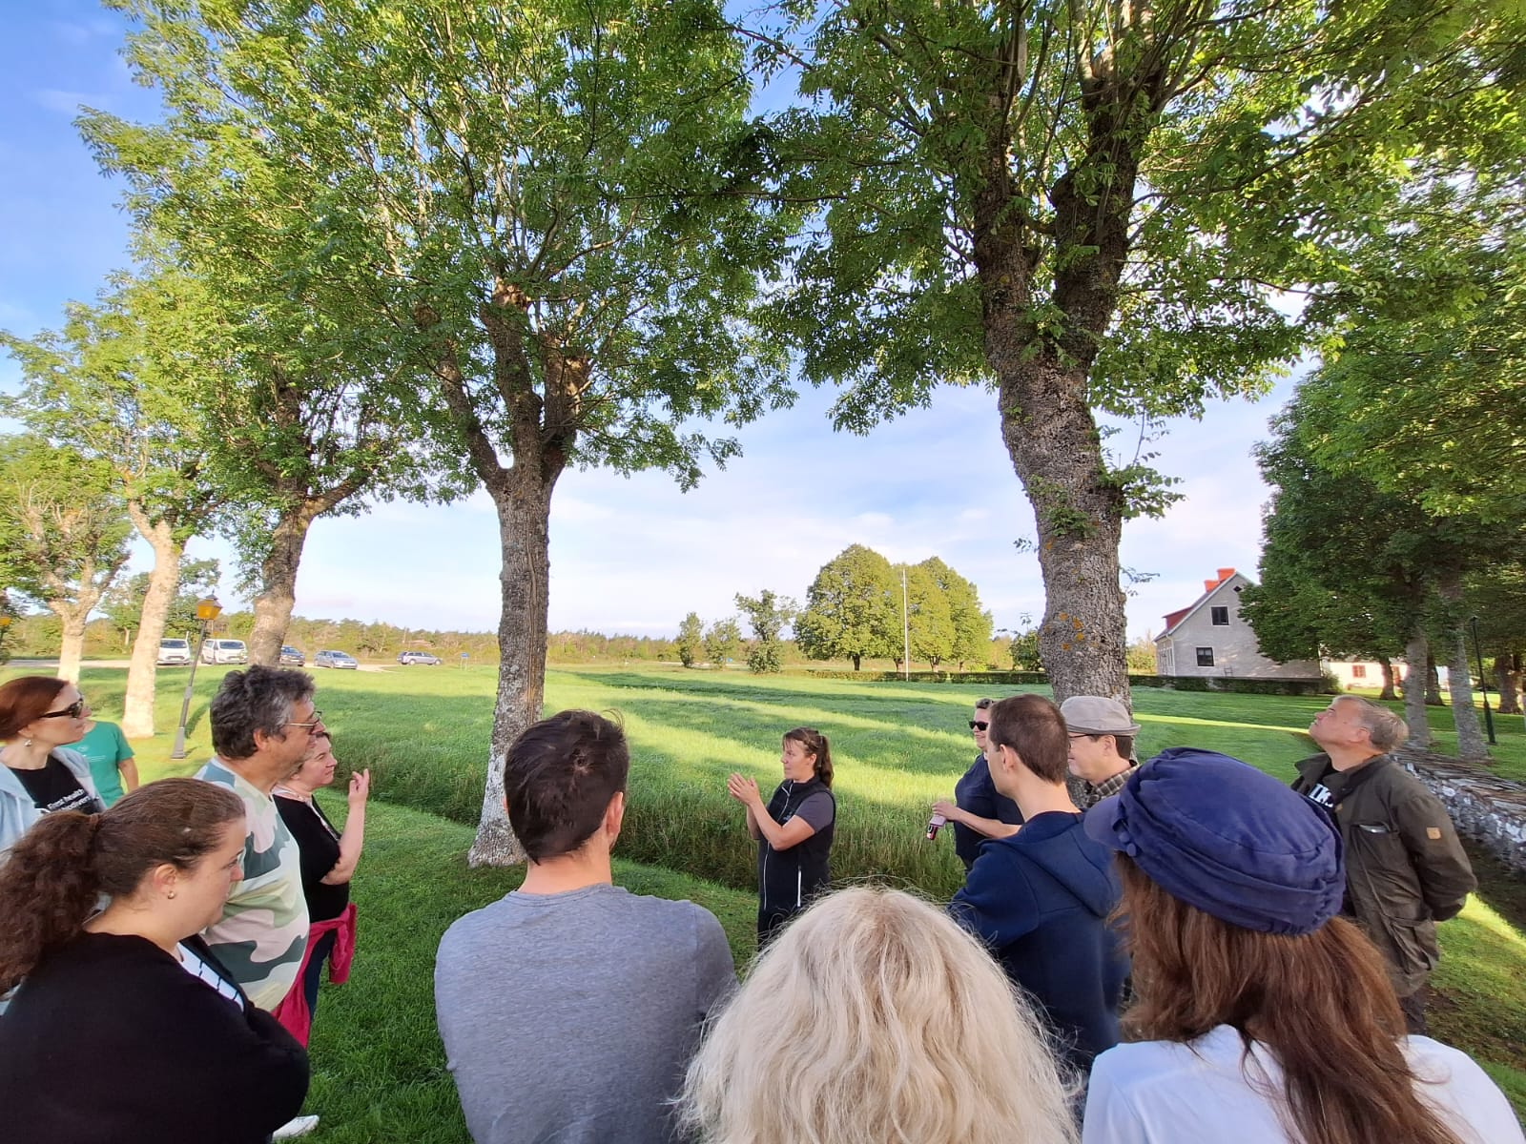
WA0072. Excursion site 2: Ash alley affected by the dieback. Presented by Amanda Overmark.

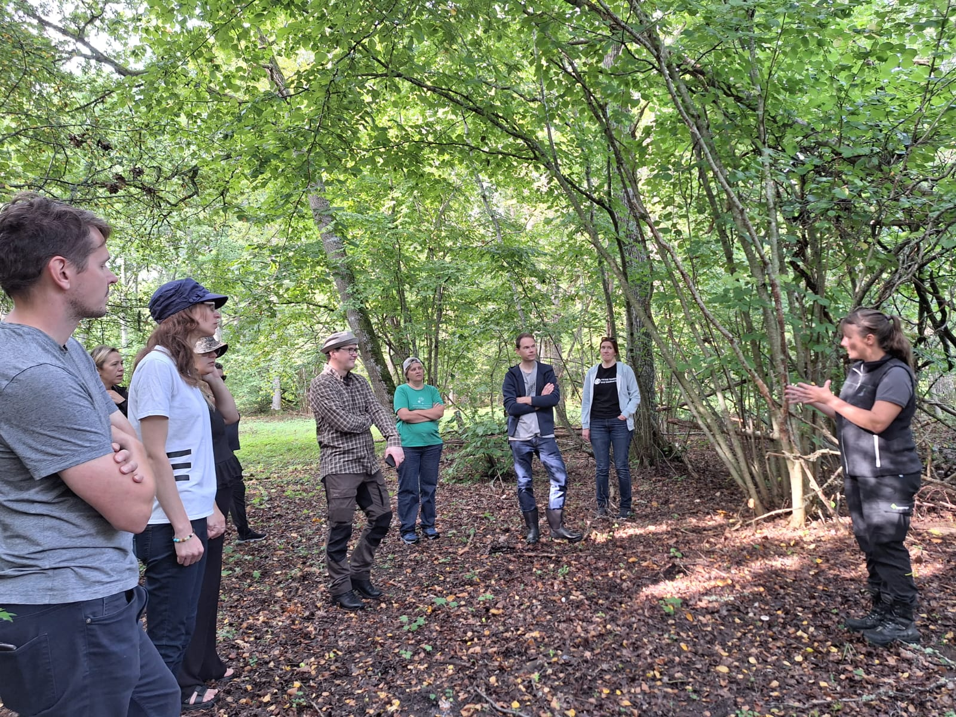
WA0095. Excursion site 3: Amanda Overmark (on the right) informing on the activities of Swedish Forest Agency aimed at restoration of Natura 2000 sites infested by Dutch Elm Disease.

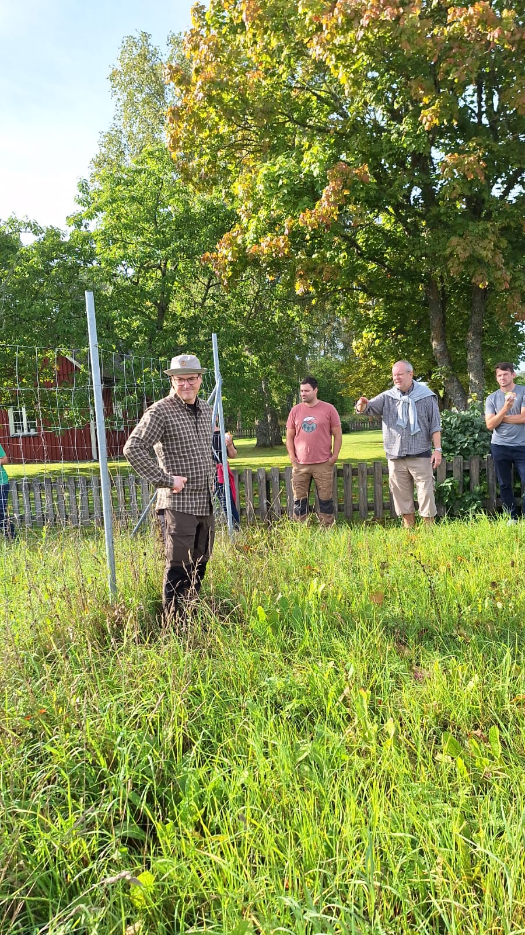
WA0028. Excursion site 4: Rimvys Vasaitis introducing participants to the plantation of “putatively dieback-resistant” ash.

