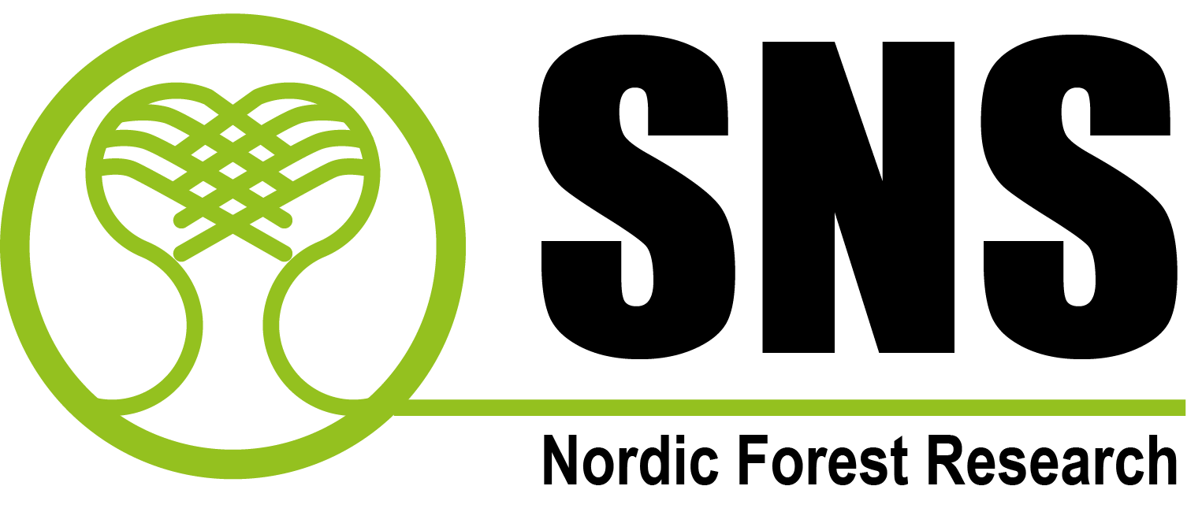

Application for joint NordGen Forest-SNS scholarships for 2018

Please note that the size of text sections in the form can be adjusted if needed.
The application should be sent to:
NordGen Forest: forest@nordgen.org

The application should be max 4 pages
1.
Application title:
2.
Applicant:
Name, Organisation, position, address, telephone, e-mail
3.
Previously received a NordGen Forest scholarship? (Yes/No)

If yes, please indicate for which purpose
4.
Aim of the activity:

5.
Time and place for activities:
6. How does the application/activity relate to NordGen Forest field of work?
www.nordgen.org/forest
7.
Please indicate if the application/activity is connected to any other ongoing Nordic forest project or activity:
8.
How does the application/activity contribute to common Nordic benefit?

9.
Expected outcome of the activity?

10.  Specification of expenses  (travel costs, meeting costs, running expenses, etc.) | Expenses | A  Applied amount (NOK) | B  Self-financing (NOK), if any
Sum
Total sum (A + B)
11.
Applicant signature, place and date

…………….………………….... ……………………… ……… …………………………….
(signature) (place) (day / month / year)

NordGen Forest Scholarship
P.O. Box 115, NO-1431 Ås
Norway
Phone: +47 45 22 70 21
E-mail: forest@nordgen.org

